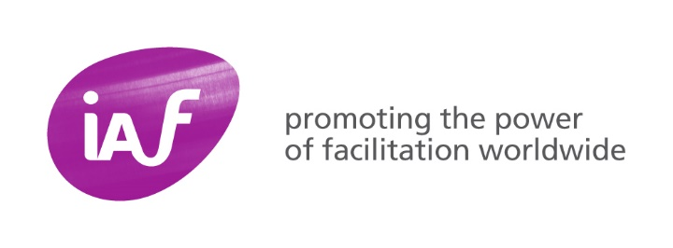

IAF Mentoring Programme Agreement

Please complete this agreement at your first session and return it to office@iaf-world.org

We voluntarily commit to the IAF Mentoring Programme for the 6-month duration of the programme.
We will:
- have a genuine interest and commitment to our mentoring relationship
- be objective, honest, supportive, and open to being challenged in a constructive way
- act ethically and respectfully always
- declare and manage any potential conflicts of interests
- respect and maintain strict confidentiality
- have at least 6 mentoring sessions during the 6-month period
- participate in the evaluation of the programme by providing feedback as requested.

We (the mentor and mentee) have participated or listened to the recording of the Mentor or Mentee orientation webinars.
We acknowledge that either person has the right to discontinue the mentoring relationship for any reason on a no-fault basis. If this should occur, the mentor agrees that he or she will advise the Mentoring Programme Lead as soon as possible.

Name of Mentee
Name of Mentor
Date

